EDA REPORT on Cardiotocographic data

OBJECTIVE:
The main goal of this assignment is to conduct a thorough exploratory analysis of the "cardiographic.csv" dataset to uncover insights, identify patterns, and understand the dataset's underlying structure. You will use statistical summaries, visualizations, and data manipulation techniques to explore the dataset comprehensively.
DATASET:
- LB - Likely stands for "Baseline Fetal Heart Rate (FHR)" which represents the average fetal heart rate over a period.
- AC - Could represent "Accelerations" in the FHR. Accelerations are usually a sign of fetal well-being.
- FM - May indicate "Fetal Movements" detected by the monitor.
- UC - Likely denotes "Uterine Contractions", which can impact the FHR pattern.
- DL - Could stand for "Decelerations Late" with respect to uterine contractions, which can be a sign of fetal distress.
- DS - May represent "Decelerations Short" or decelerations of brief duration.
- DP - Could indicate "Decelerations Prolonged", or long-lasting decelerations.
- ASTV - Might refer to "Percentage of Time with Abnormal Short Term Variability" in the FHR.
- MSTV - Likely stands for "Mean Value of Short Term Variability" in the FHR.
- ALTV - Could represent "Percentage of Time with Abnormal Long Term Variability" in the FHR.
- MLTV - Might indicate "Mean Value of Long-Term Variability" in the FHR.

SUMMARY:
Performing EDA on the Cardiotocographic dataset had begun by importing pandas, NumPy, Matplotlib and Seaborn libraries. These libraries are used for working for numerical and statistical data along with their visualizations. The data consists of entire float datatype with 2126 rows and 14 columns.
'df.isnull().sum()' is used to identify the missing values and they were filled with mean. Replacing the NaN values with mean helps in reducing deviations of the statistical values. Many outliers were detected in each category and are removed.
'df.describe()' is used to describe the statistical summary of the dataset. Parameters like mean, median, mode, standard deviation, min and max values, 25th percentile, 50th percentile and 75th percentile are displayed for each category.
 | LB | AC | FM | UC | DL | DS | DP | ASTV | MSTV | ALTV | MLTV | Width | Tendency | NSP
count | 2126.000000 | 2126.000000 | 2126.000000 | 2126.000000 | 2126.000000 | 2126.000000 | 2126.000000 | 2126.000000 | 2126.000000 | 2126.000000 | 2126.000000 | 2126.000000 | 2126.000000 | 2126.0
mean | 133.343598 | 0.003219 | 0.009894 | 0.004391 | 0.001895 | 0.000003 | 0.000175 | 46.995984 | 1.364378 | 10.285964 | 8.284887 | 70.429260 | 0.316371 | 1.0
std | 11.214328 | 0.004370 | 0.067540 | 0.003340 | 0.003343 | 0.000141 | 0.000836 | 18.813973 | 1.173632 | 21.205041 | 7.734356 | 42.719161 | 0.642424 | 0.0
min | 51.842487 | -0.019284 | -0.480634 | -0.014925 | -0.015393 | -0.001353 | -0.005348 | -63.000000 | -6.600000 | -91.000000 | -50.700000 | -174.000000 | -3.000000 | 1.0
25% | 126.000000 | 0.000000 | 0.000000 | 0.001851 | 0.000000 | 0.000000 | 0.000000 | 32.000000 | 0.700000 | 0.000000 | 4.600000 | 37.000000 | 0.000000 | 1.0
50% | 133.000000 | 0.001668 | 0.000000 | 0.004484 | 0.000000 | 0.000000 | 0.000000 | 49.000000 | 1.200000 | 0.000000 | 7.500000 | 68.000000 | 0.000000 | 1.0
75% | 140.000000 | 0.005606 | 0.002567 | 0.006536 | 0.003289 | 0.000000 | 0.000000 | 61.000000 | 1.700000 | 11.000000 | 10.800000 | 100.000000 | 1.000000 | 1.0
max | 214.000000 | 0.038567 | 0.961268 | 0.030002 | 0.030769 | 0.002706 | 0.010695 | 162.000000 | 13.800000 | 182.000000 | 101.400000 | 357.000000 | 3.000000 | 1.0

Histograms:
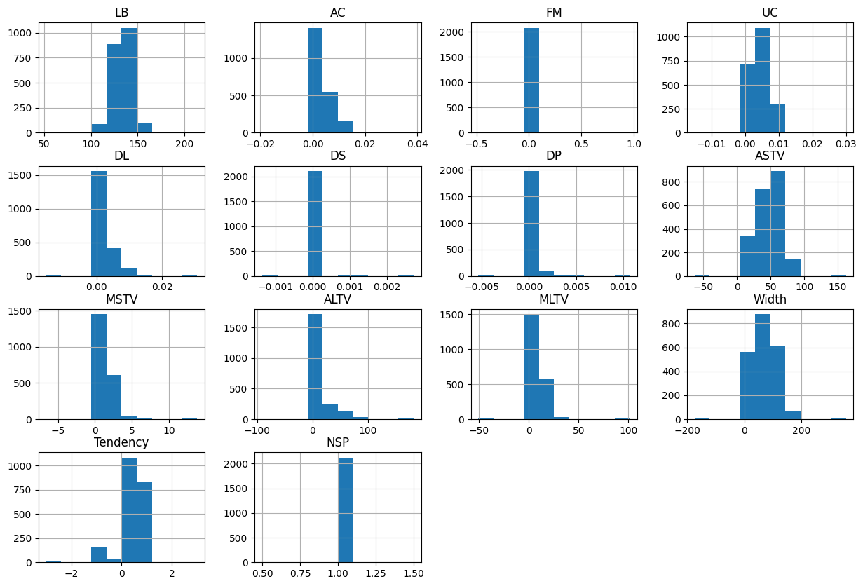
- LB (Fetal Heart Rate Baseline): Slightly left-skewed, with a visible peak around 130-140.
- AC (Accelerations): Highly right-skewed, with a large concentration of values at or near zero, indicating infrequent accelerations.
- FM (Fetal Movement): Extremely right-skewed, with most values at zero.
- UC (Uterine Contractions): Right-skewed, similar to AC, with a concentration near zero and a tail extending to higher values.
- DL (Decelerations): Similar to AC and UC, right-skewed with most values at zero.
- DS (Severe Decelerations): Appears heavily concentrated at zero.
- DP (Prolonged Decelerations): Also heavily concentrated at zero.
- ASTV (Percentage of Time with Abnormal Short Term Variability): Spans a wide range.
- MSTV (Mean Short Term Variability): Right-skewed.
- ALTV (Percentage of Time with Abnormal Long Term Variability): Highly right-skewed, with a large number of zero values.
- MLTV (Mean Long Term Variability): Right-skewed.
- Width (Histogram Width): Shows a relatively broad distribution, with some central tendency but also spread.
- Tendency (Histogram Tendency): Have values clustered around 0 and 1.
- NSP (Fetal State Class Code): The histogram for NSP shows a single bar at 1.0.

Boxplots:
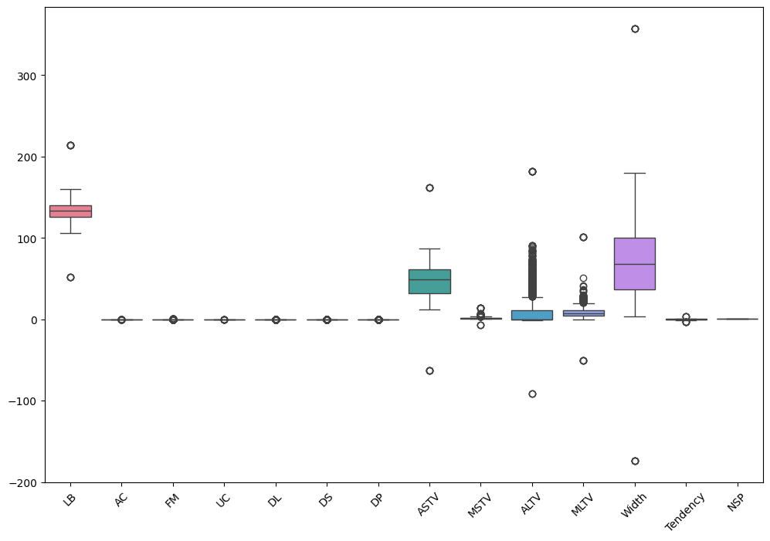
The boxplots generally confirm the skewness observed in the histograms. Many variables like AC, FM, UC, DL, DS, DP, ALTV, and MLTV show a significant number of points extending far beyond the whiskers, indicating a high presence of outliers. This is consistent with the output from the outlier detection step which showed a large number of outliers for most columns.
Correlation Heatmap:
The heatmap is a visual representation of the correlation matrix.
Positive Correlation: Values closer to +1 (often represented by darker/warmer colours) mean that as one variable increases, the other also tends to increase.
Negative Correlation: Values closer to -1 (often represented by lighter/cooler colours) mean that as one variable increases, the other tends to decrease.
No Correlation: Values closer to 0 (often mid-range colours) mean there's little to no linear relationship between the variables.
Diagonal: The diagonal line (correlation of a variable with itself) will always be 1, indicating a perfect positive correlation.
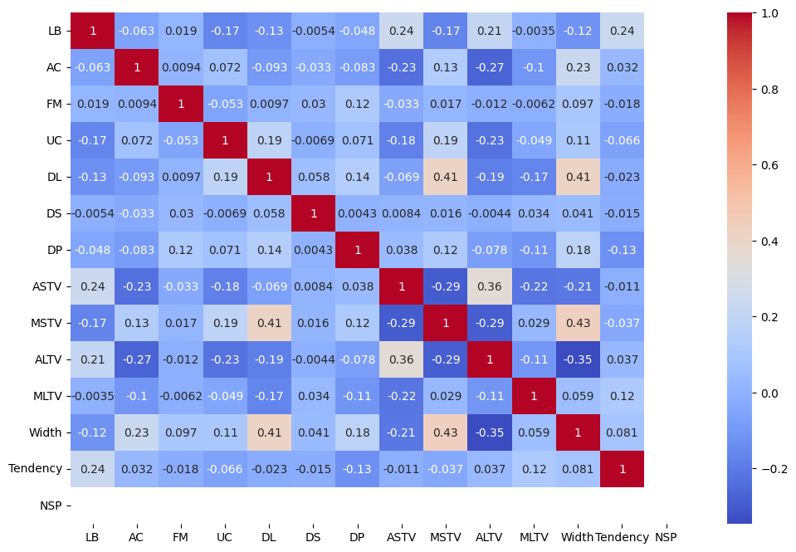
The heatmap shows varying degrees of correlation between variables.
Strong Positive Correlations: Significant positive correlations are observed between DL and Width (0.36), MSTV and Width (~0.38). This suggests that as one of these variables increases, the other tends to increase as well.
Moderate Correlations: LB shows a moderate positive correlation with Tendency (0.19). AC shows a moderate positive correlation with Width (~0.24).
Weak/No Correlations: Many pairs exhibit very weak correlations (close to 0), such as LB-AC, FM-UC, DS-AC, LB-UC, DP-DS, indicating little to no linear relationship.
Negative Correlations: ASTV shows moderate negative correlation with MSTV (0.23), suggesting an inverse relationship. ALTV also shows negative correlations with Width and MSTV.

Violin Plots:
The violin plots provide the data density. The violin plot displays the density of variables present in a range of frequencies. It shows the where the variables are in the certain range of frequencies and their density. It helps to provide deeper insights. The narrowness represents the less density of variables whereas wideness shows more density.
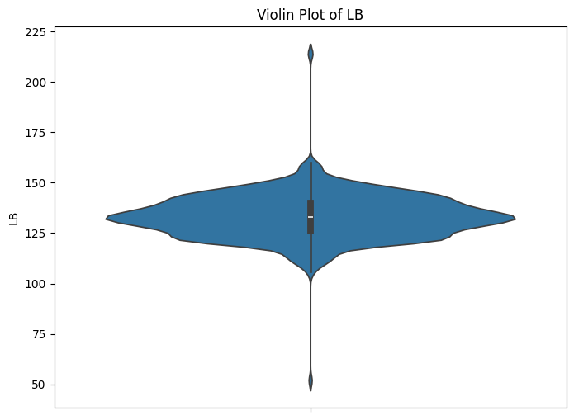
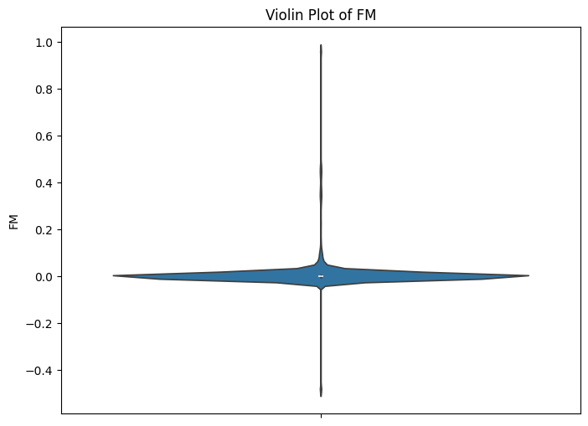
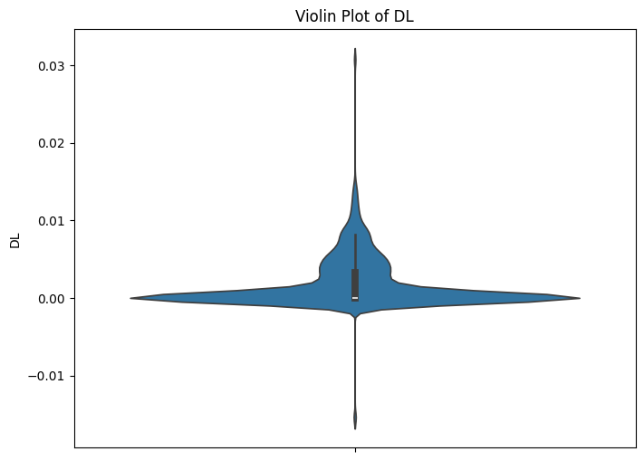
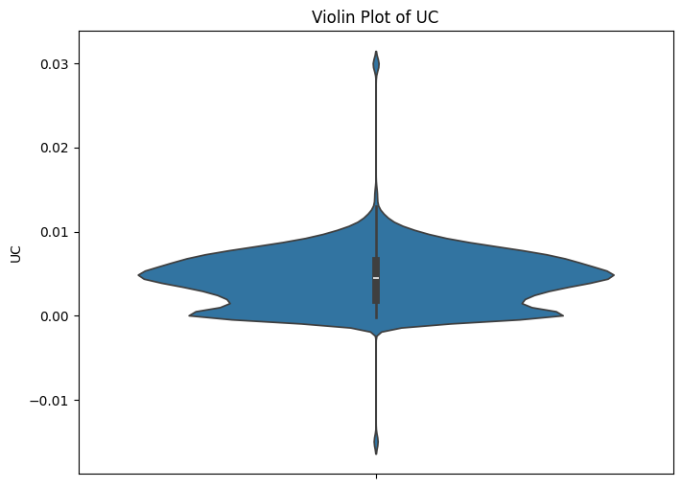
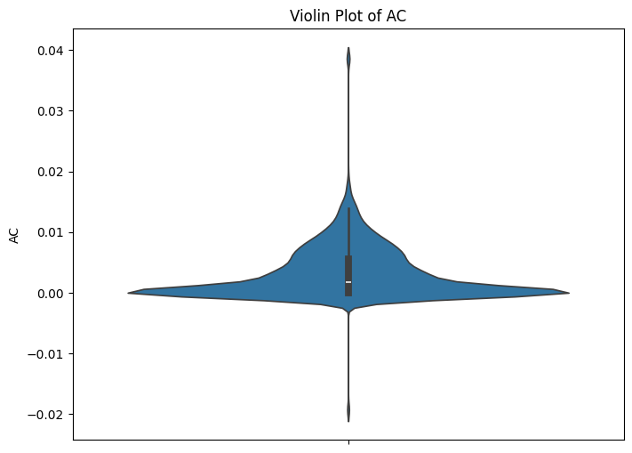
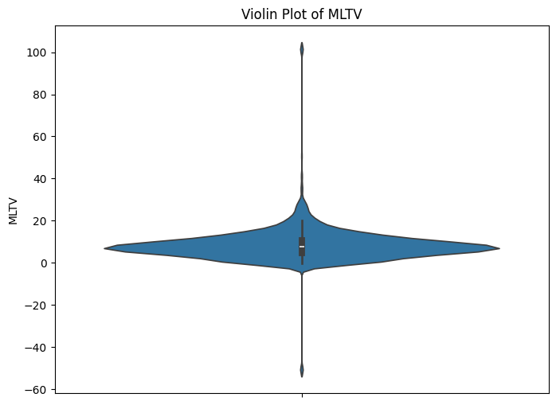
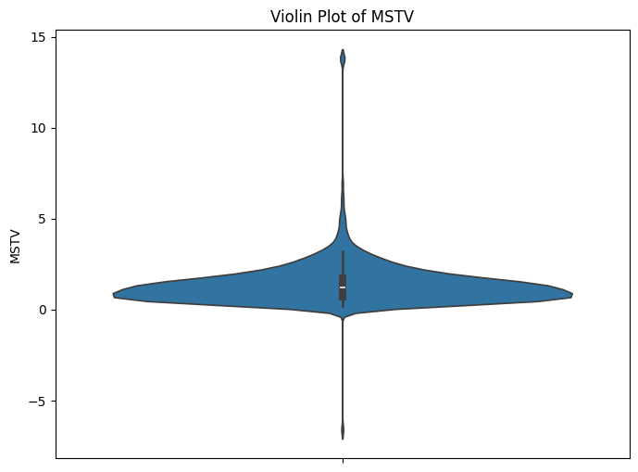
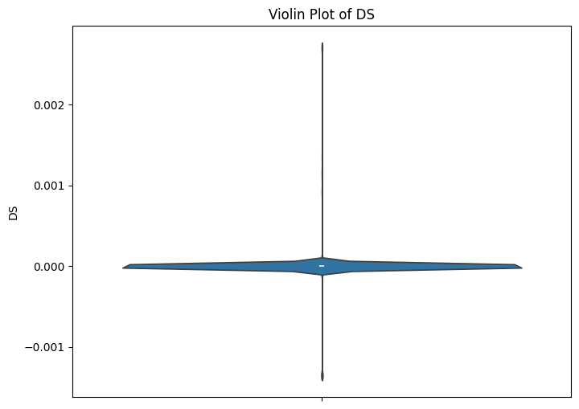
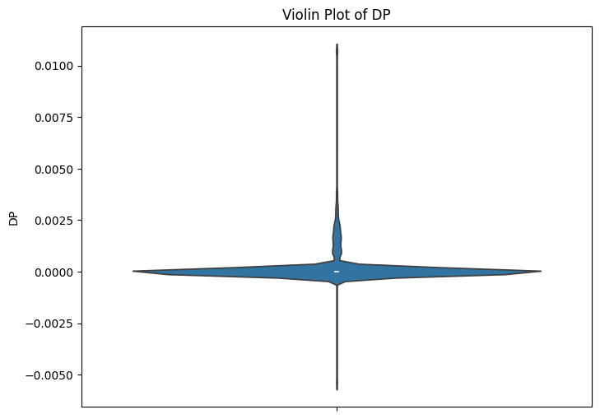
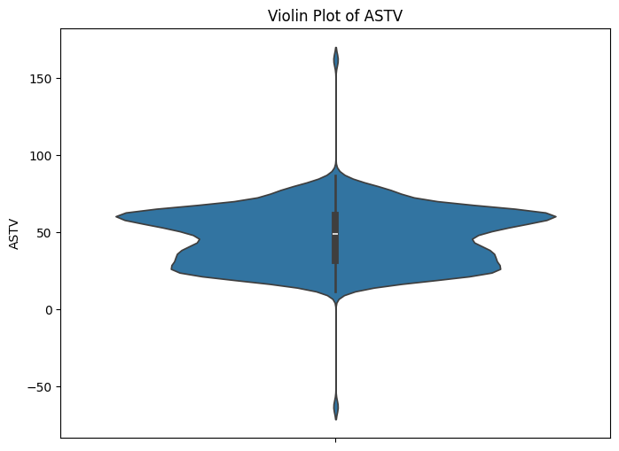
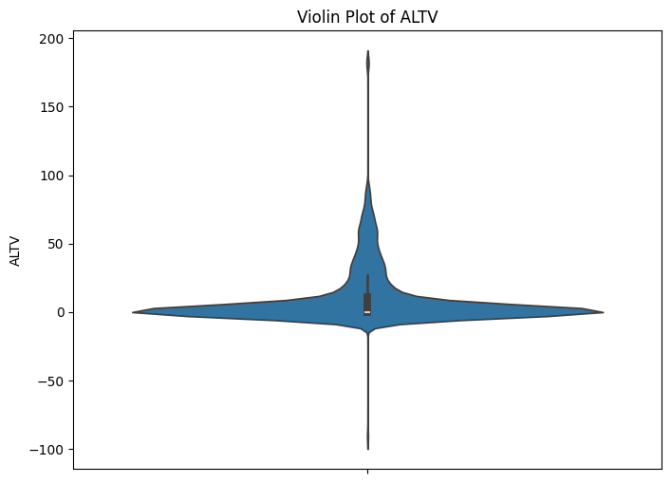
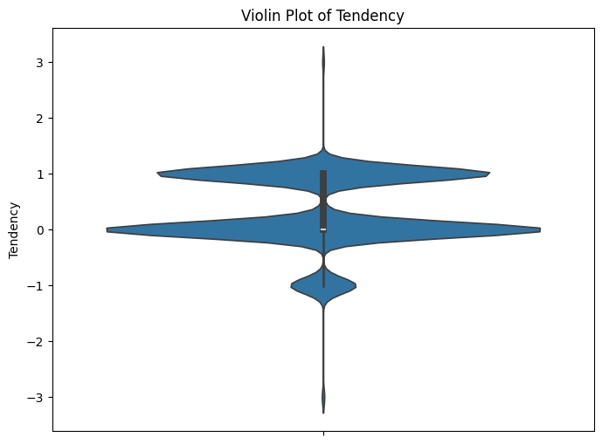
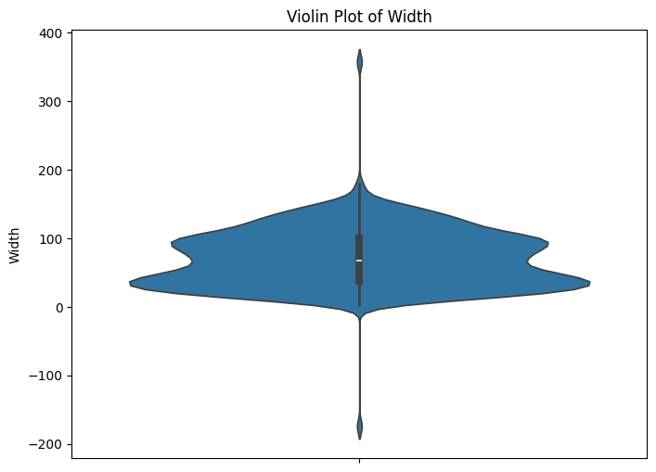
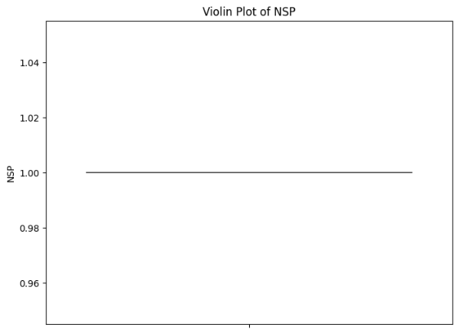
For variables like AC, FM, UC, DL, DS, DP, ALTV, and MLTV, the violin plots clearly show high density at zero, with narrow, and then extending to wider sections for higher values, confirming the right-skewness and presence of scattered higher values (outliers).
For LB, ASTV, MSTV, Width, and Tendency, the violin plots show where the majority of values are concentrated and how dense they are.
The NSP violin plot is a single line at 1.0.
Although the bar plot is plotted, the dataset doesn’t contain any categorial variables.
Future Recommendations:
More effective outlier treatment to provide good results.
Deployment of the data in an ML model.
.ipynb link:

